**Assignment no:5**

**Problem Statement: Create a Public Bucket in AWS, upload a file and give the necessary permission to check if the URL is working or not.**

**Solution Process:**

1. Go to the AWS console and search S3 and click on that.

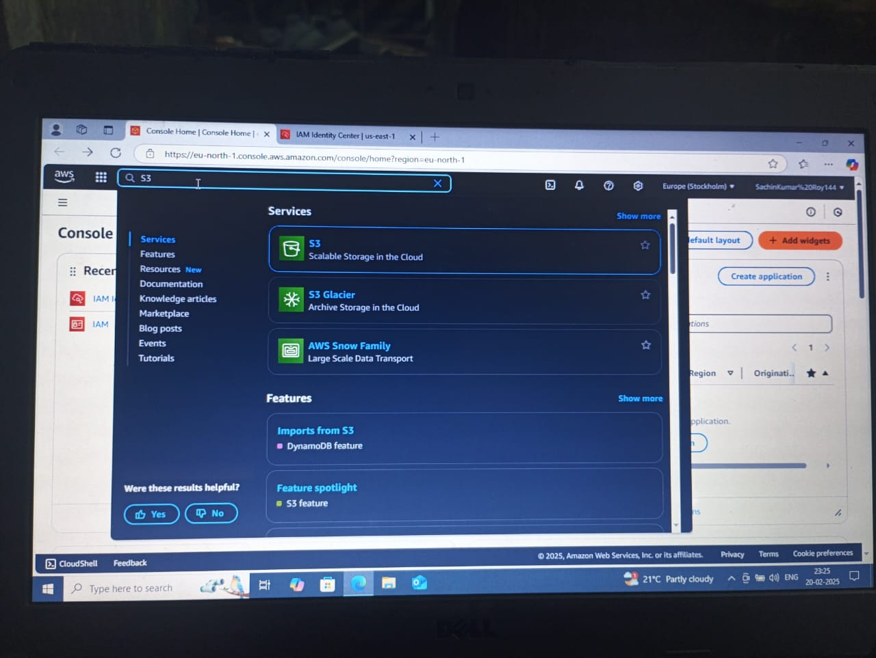

2. Then click on create bucket, after that click the region and set the region as

“Mumbai”.

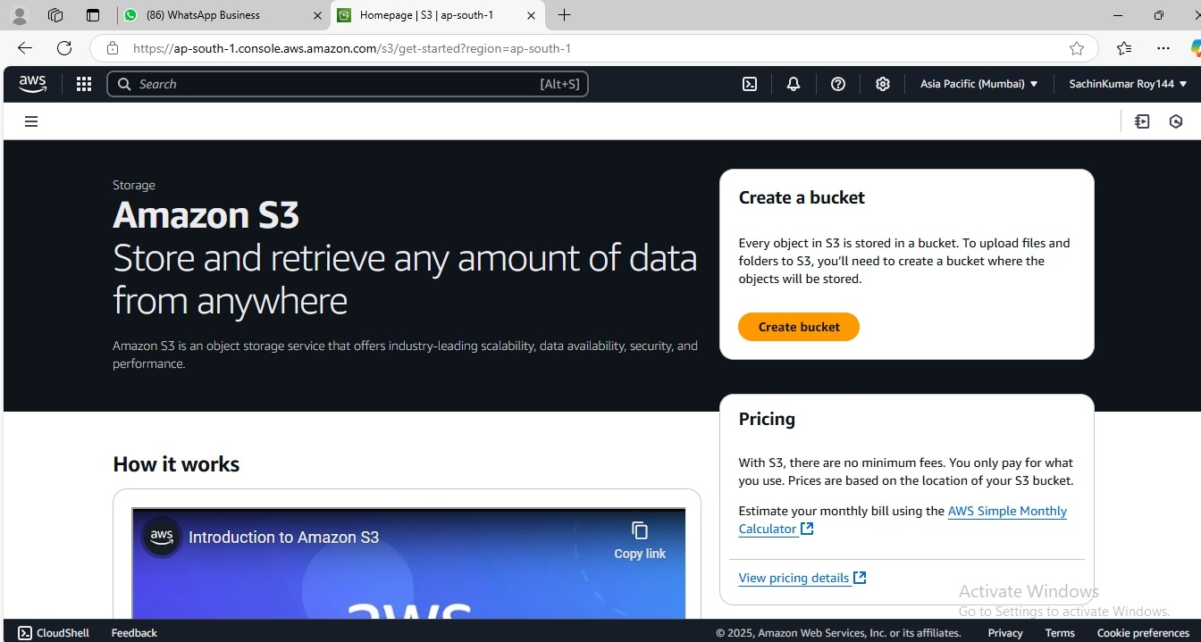

3. Give a unique bucket name.

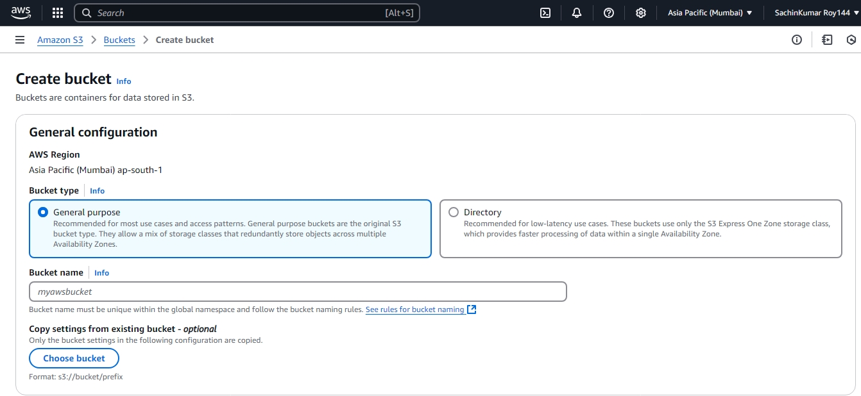

4. Now click on the ACLS Enabled and uncheck the Block all public access.

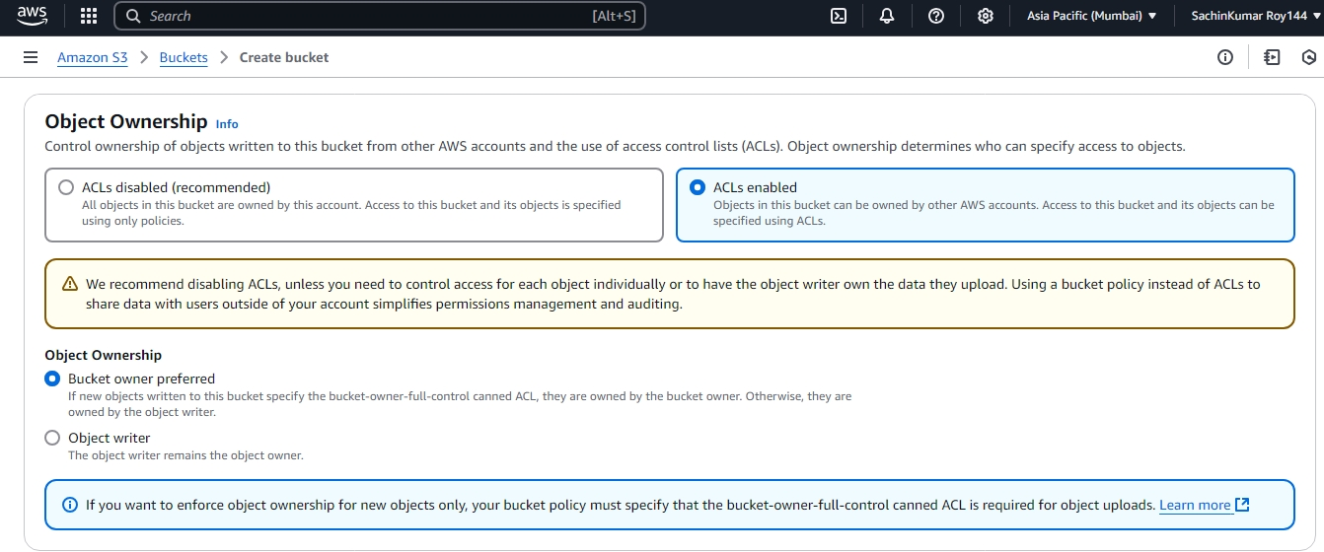

5. Then click on the bucket name.

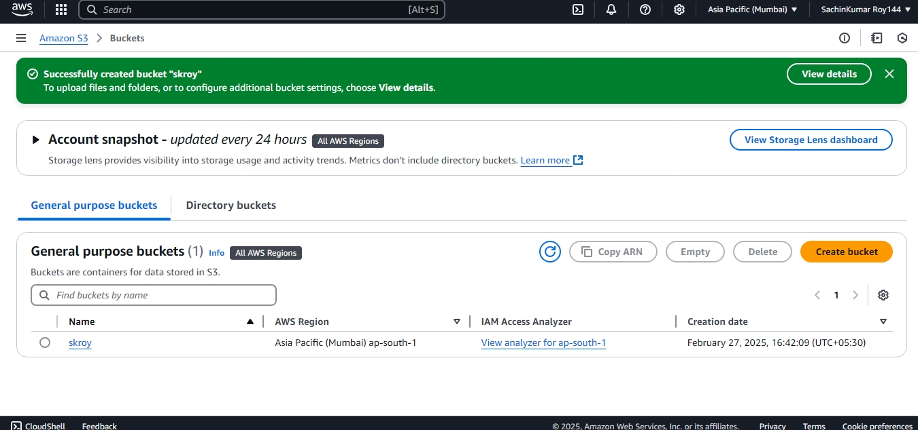

6. Now add files in the bucket. Choose any document or any picture from your pc and upload that.

7. After uploading the file, click close on the next page.

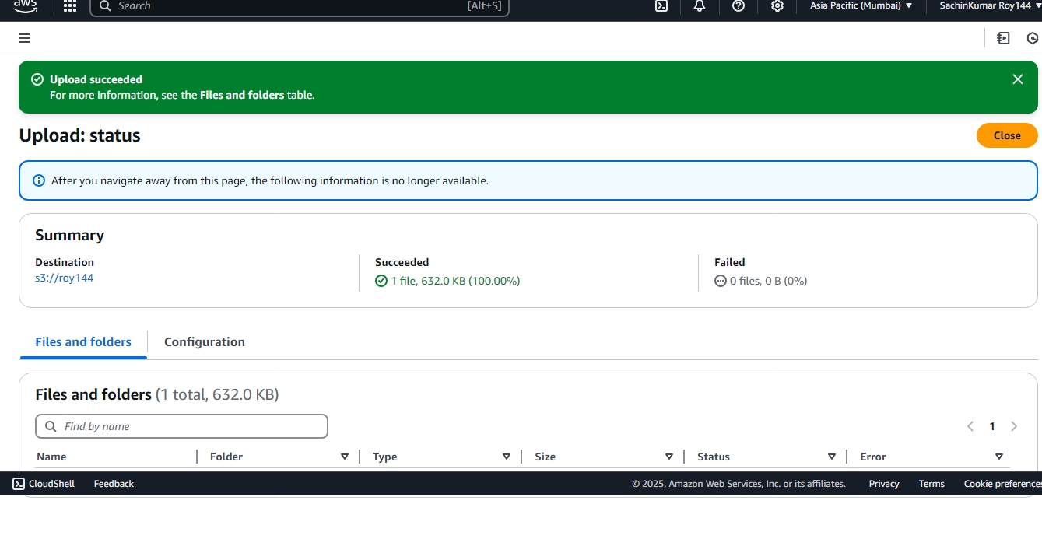

8. Then go to S3 and click the General purpose buckets and click the doc which you uploaded recently.

9. Then copy the URL of that uploaded doc or files.

10. Now open an incognito tab and paste the URL and you have permission to deny

page.

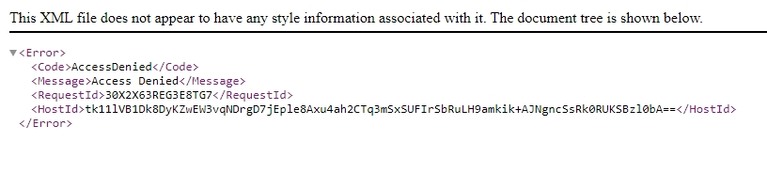

11. Now again you upload another file, and in this page go for permission and access the Grant public access then upload.

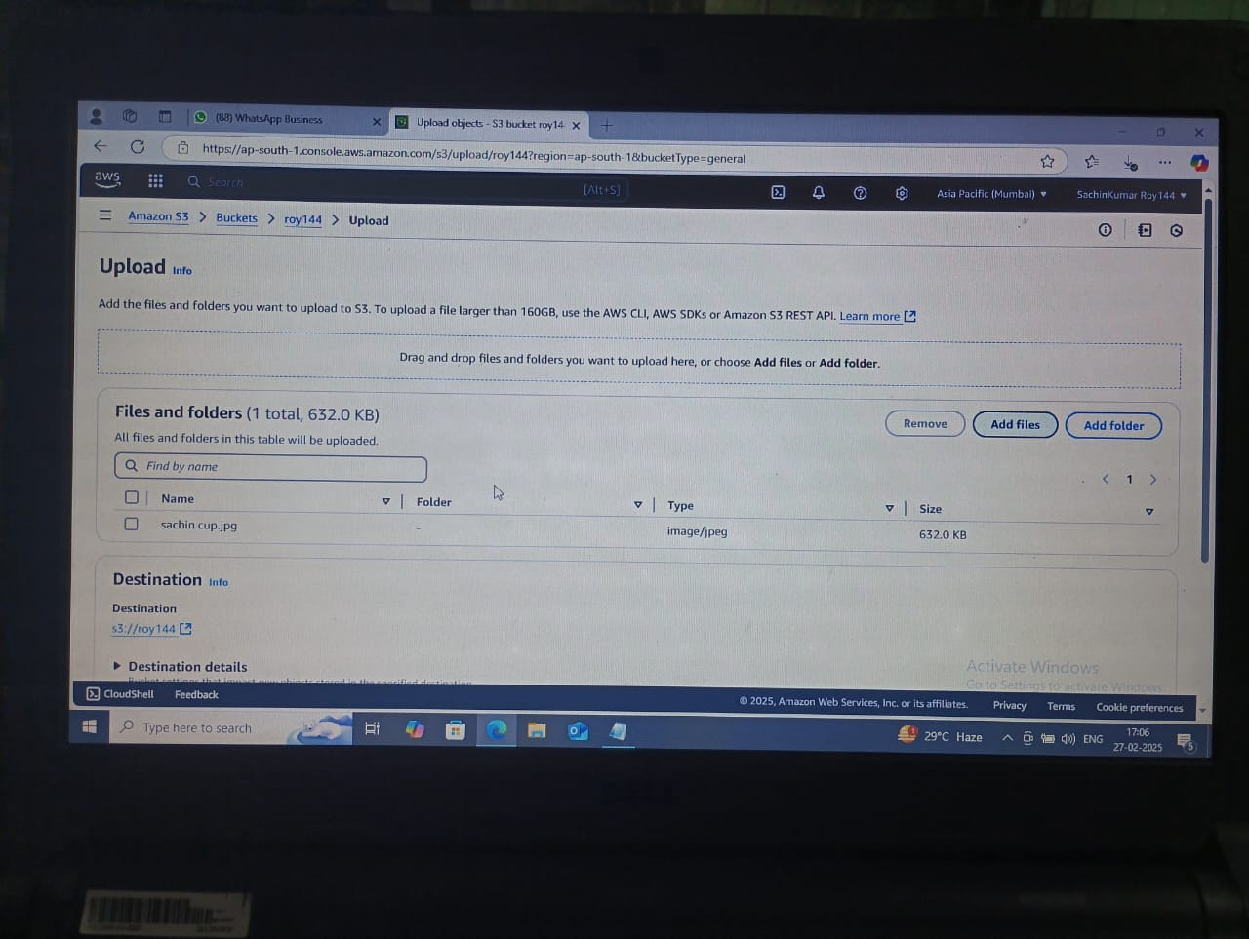

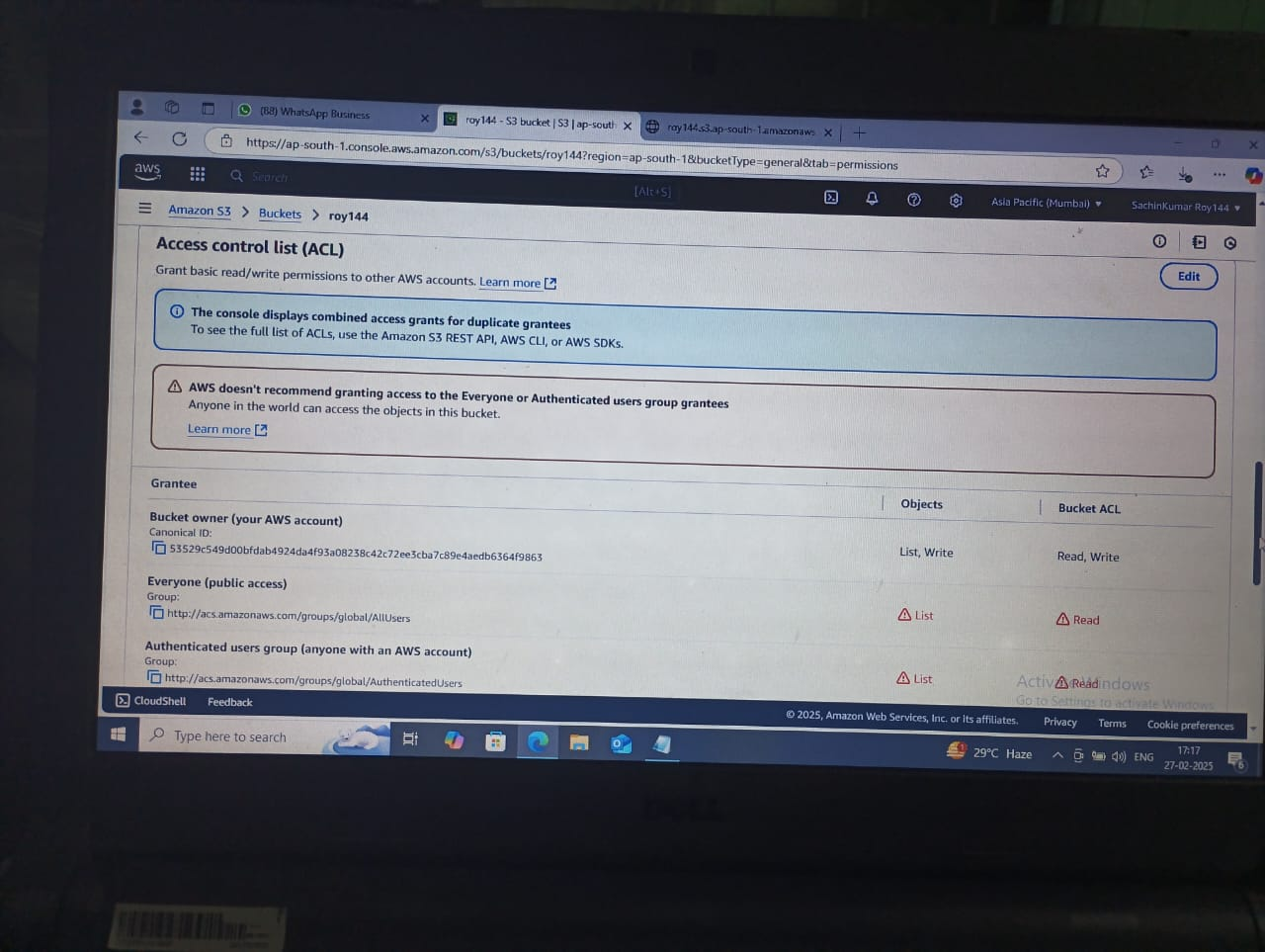



12. Now click on the new file which you have been added recently and copy the URL of that file.

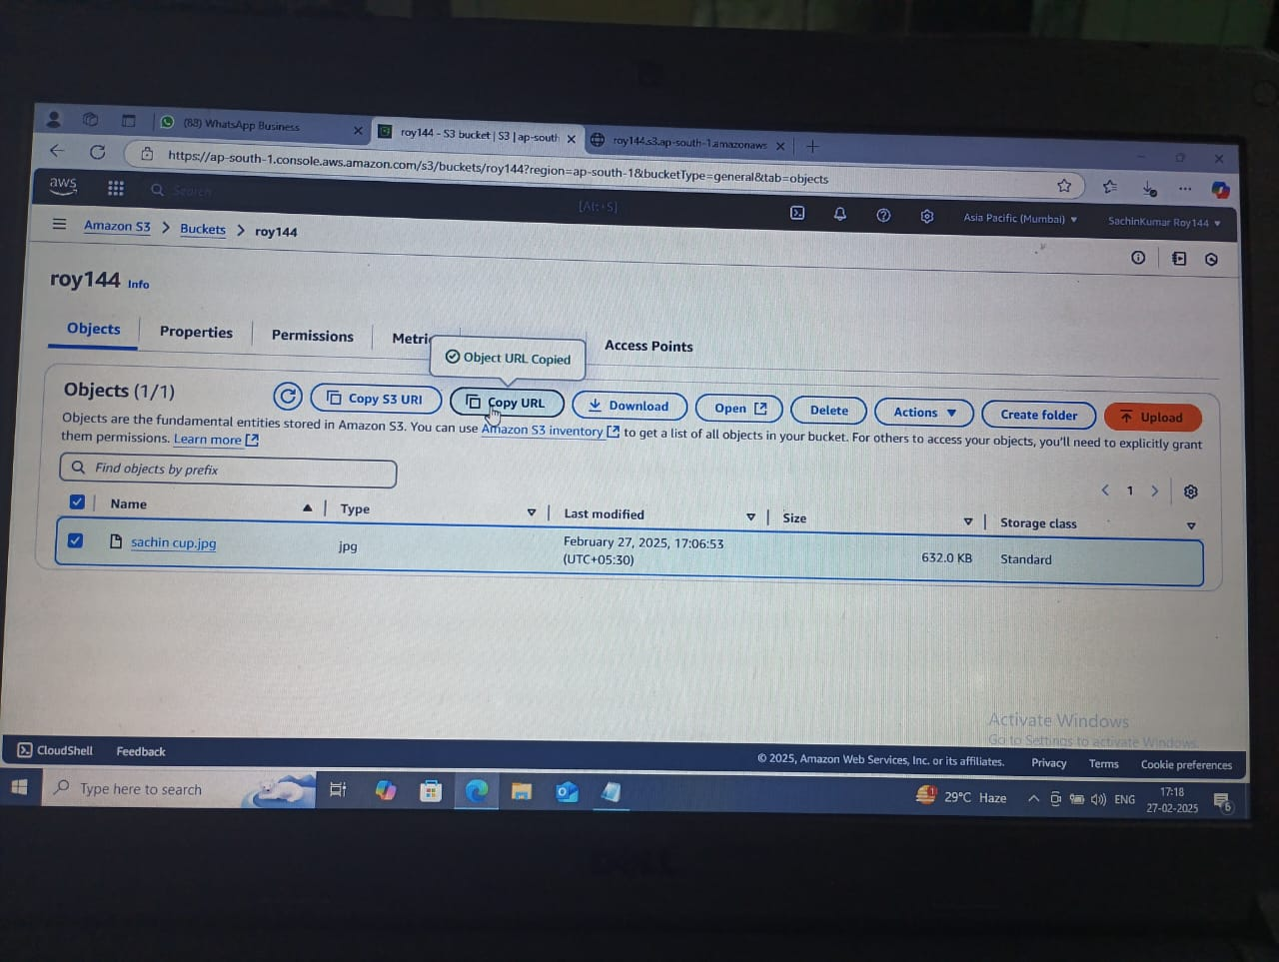

13.Paste the URL on the new incognito tab and you will get the document that you have uploaded.

